Implementation Flow:
1. Create S3 bucket
2. Create IAM Policy
3. Create IAM Role
4. Allow user to assume role
5. Setup local machine (Python + AWS CLI)
6. Write Python script
7. Run & verify

- Create S3 bucket:
Go to S3 Click Create bucket Enter:
  - Bucket name: sts-boto3-poc-043
  - Region: ap-south-2
Click Create
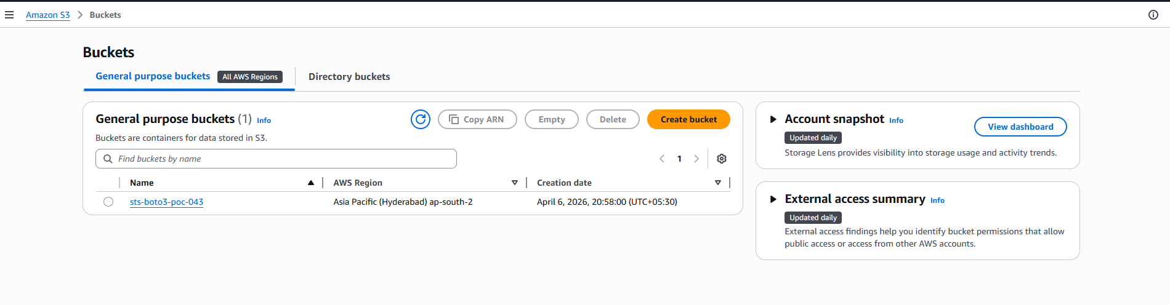
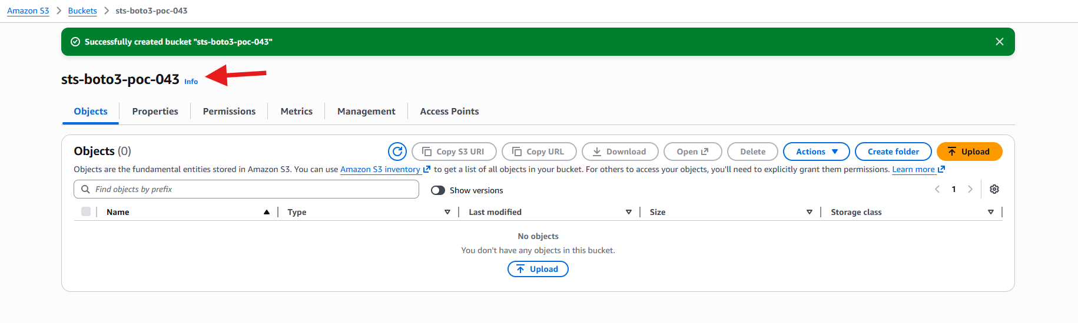
- Create IAM Policy
Go to IAM → Policies → Create Policy → JSON
Paste this:
{
"Version": "2012-10-17",
"Statement": [
{
"Effect": "Allow",
"Action": ["s3:ListBucket"],
"Resource": "arn:aws:s3:::sts-boto3-poc-043"
},
{
"Effect": "Allow",
"Action": ["s3:GetObject", "s3:PutObject", "s3:DeleteObject"],
"Resource": "arn:aws:s3:::sts-boto3-poc-043/*"
}
]
}
Click Next → Name: S3-STS-Policy done

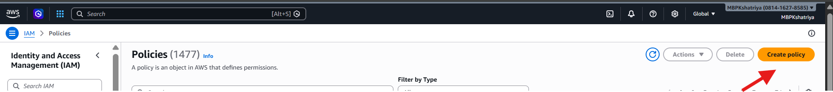
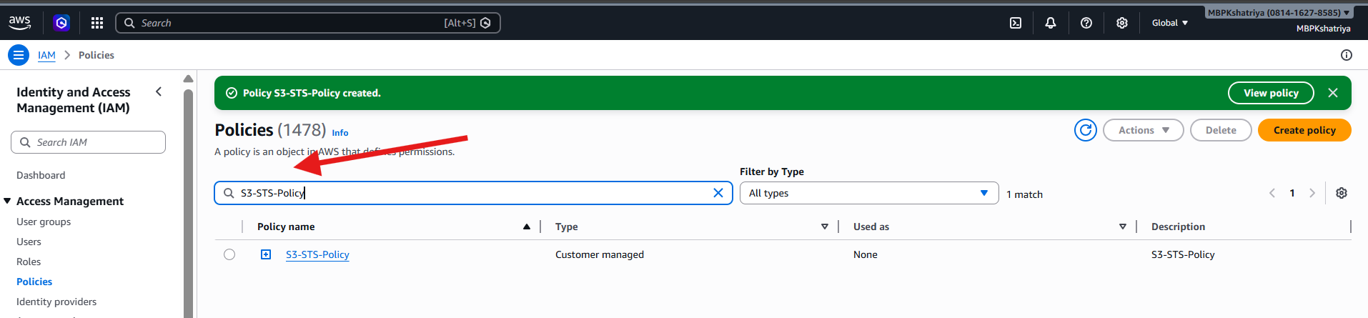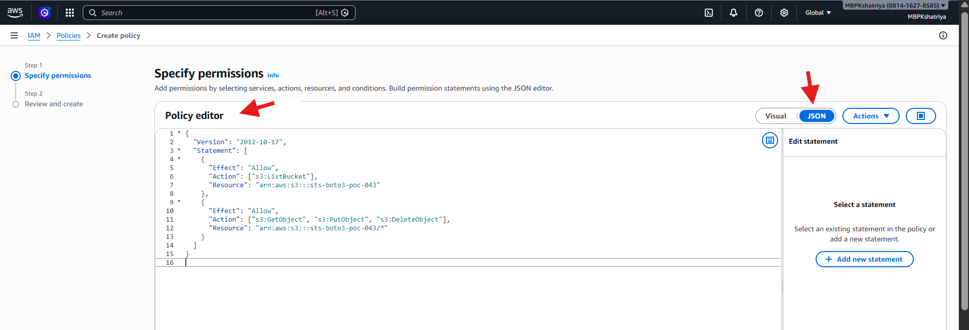

- Create IAM Role

IAM → Roles → Create Role
- Trusted entity: AWS account
- Select: This account
- Click Next
- Attach policy:
✔ S3-STS-Policy
- Role name: S3-STS-Role create role.
- Copy Role ARN
- Example: arn:aws:iam::081416278585:role/S3-STS-Role
- Save it.

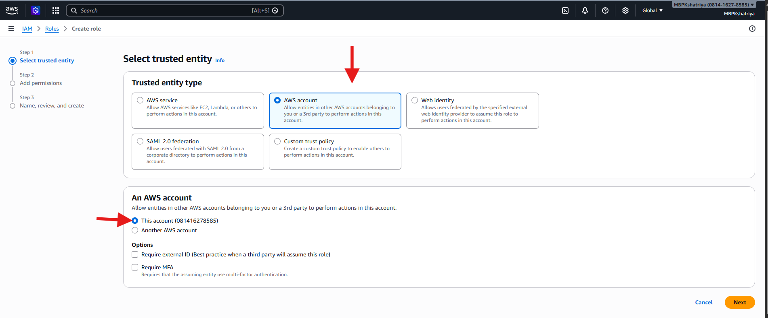
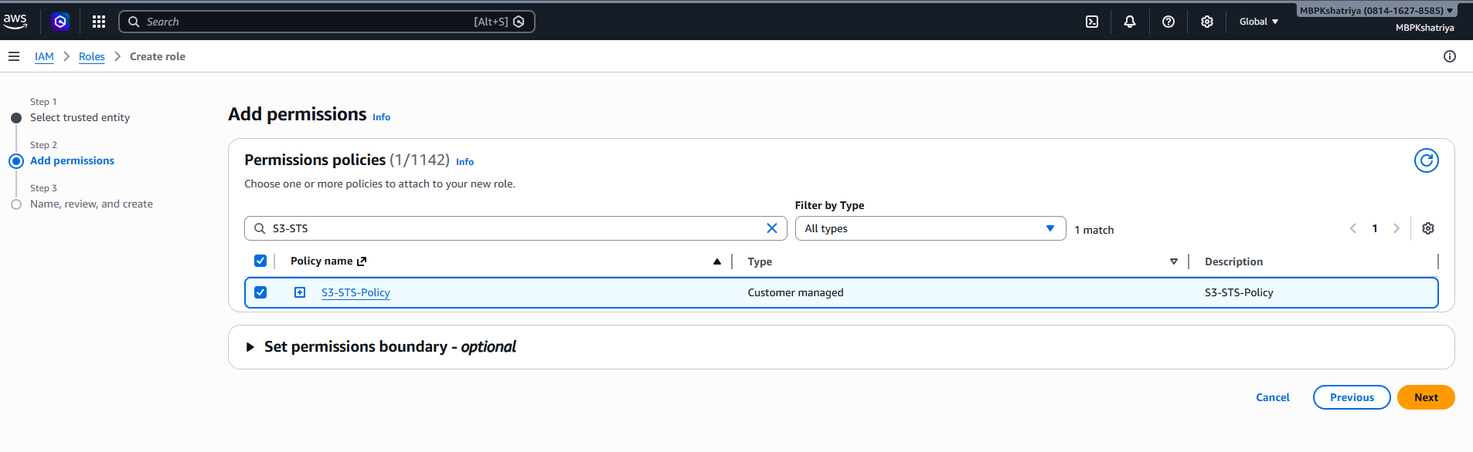
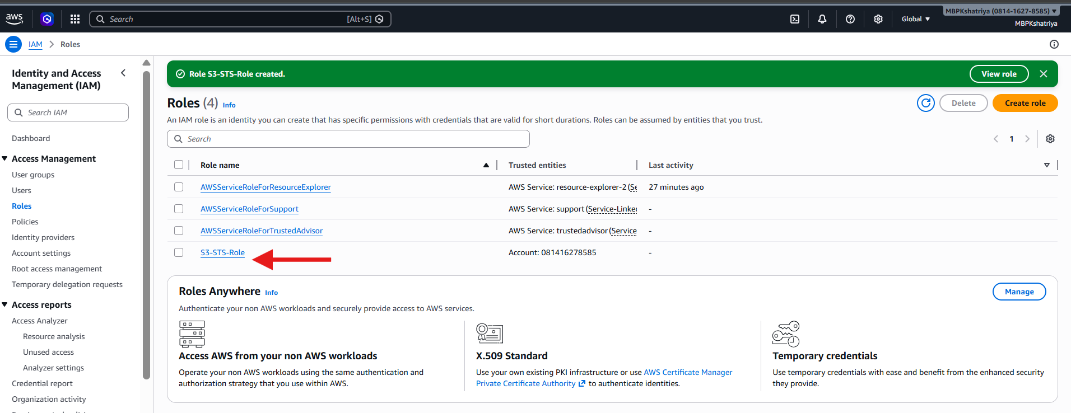

- Allow Your User to Assume Role

Open Role → Trust relationships → Edit

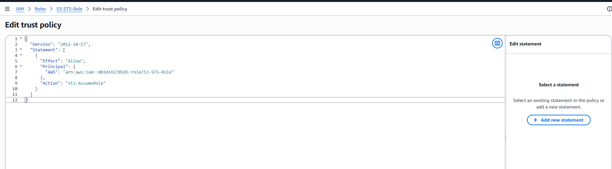

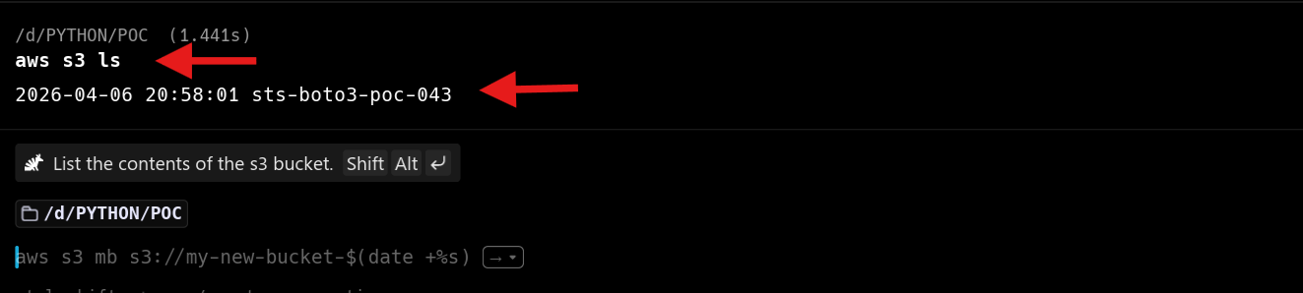

Output: file upload
